# *Front-End UI/UX Mini Project*

## *Project Report*

### *1. Title Page*

Project Title: Spoon of Malabar – Restaurant Website  
Submitted By:

Likhith Vinoy

2460400

likhith.vinoy@btech.christuniversity.in

Aadhin Benny

2460483

[aadhin.benny@btech.christuniversity.in](mailto:aadhin.benny@btech.christuniversity.in)

Basil Baby

2460484

[basil.baby@btech.christuniversity.in](mailto:basil.baby@btech.christuniversity.in)

Course: UI/UX Front End Developement  
Instructor Name: Narendra   
Institution: Christ(Deemed to be University),Kengeri Campus  
Date of Submission: 13/08/2025

### *2. Abstract*

This project is a fully responsive restaurant website called 'Spoon of Malabar', built using HTML5 and CSS3. The goal was to design an engaging, user-friendly platform to showcase the restaurant's menu, story, and contact information. The website features a visually appealing hero section, categorized menu items with images and pricing, and a responsive layout that adapts seamlessly across devices. Core technologies include HTML5 for semantic structure and CSS3 for layout, styling, and responsiveness. The final outcome provides an inviting online presence for the restaurant, enhancing customer engagement and brand visibility.

### *3. Objectives*

- Design a visually appealing restaurant website to promote Spoon of Malabar.

- Implement a responsive layout for optimal viewing on desktop, tablet, and mobile.

- Organize menu items into categories with images, prices, and ratings.

- Create an informative 'About Us' section to build brand connection.

- Ensure easy navigation to key sections such as Menu, About, and Contact.

### *4. Scope of the Project*

The project focuses on front-end development only, using HTML5 and CSS3.  
It includes a hero banner, categorized menu sections, an about section, and a contact section.  
The site is optimized for multiple screen sizes and prioritizes usability and visual appeal.  
No backend or ordering system is implemented in this version.

### *5. Tools & Technologies Used*

|  |  |
| --- | --- |
| ***Tool / Technology*** | ***Purpose*** |
| *HTML5* | *Content structure and semantic markup* |
| *CSS3* | *Styling, layout, animations, and responsiveness* |
| *VS Code* | *Code editing* |
| *Chrome DevTools* | *Testing and debugging* |

### *6. HTML Structure Overview*

- Semantic tags used: <header>, <nav>, <section>, <footer>.  
- Hero section with title, tagline, and call-to-action button.  
- Menu categorized into Starters, Mains, and Desserts.  
- About section with image and description.  
- Contact section with address, phone, and working hours.

### *7. CSS Styling Strategy*

- Inline <style> in the HTML head for direct CSS definition.  
- Flexbox used for layout arrangements.  
- CSS Grid used for displaying menu categories.  
- Color palette inspired by warm, earthy tones to represent Kerala cuisine.  
- Hover effects for interactive feel on menu cards.  
- Media queries for responsiveness across devices.

### *8. Key Features*

|  |  |
| --- | --- |
| ***Feature*** | ***Description*** |
| *Responsive Design* | *Adapts seamlessly to all screen sizes* |
| *Hero Banner* | *Visually engaging welcome section with CTA* |
| *Categorized Menu* | *Menu items organized into starters, mains, and desserts* |
| *About Section* | *Background story and brand identity* |
| *Contact Section* | *Easy access to location, phone, and timings* |

### *9. Challenges Faced & Solutions*

|  |  |
| --- | --- |
| ***Challenge*** | ***Solution*** |
| *Image alignment in menu grid* | *Applied CSS Grid and object-fit to maintain proportions* |
| *Text readability over background image* | *Added semi-transparent overlay* |
| *Maintaining consistent styling across sections* | *Defined a cohesive color scheme and typography* |

### *10. Outcome*

The Spoon of Malabar website successfully presents the restaurant's offerings in an appealing and organized format. It delivers a positive first impression, ensures smooth navigation, and adapts to different devices without compromising user experience.

### *11. Future Enhancements*

- Integrate online ordering and payment gateway.

- Add a booking/reservation form.

- Include customer reviews and testimonials.

- Add animations for smoother menu browsing.

### *12. Screenshots of Final Output*

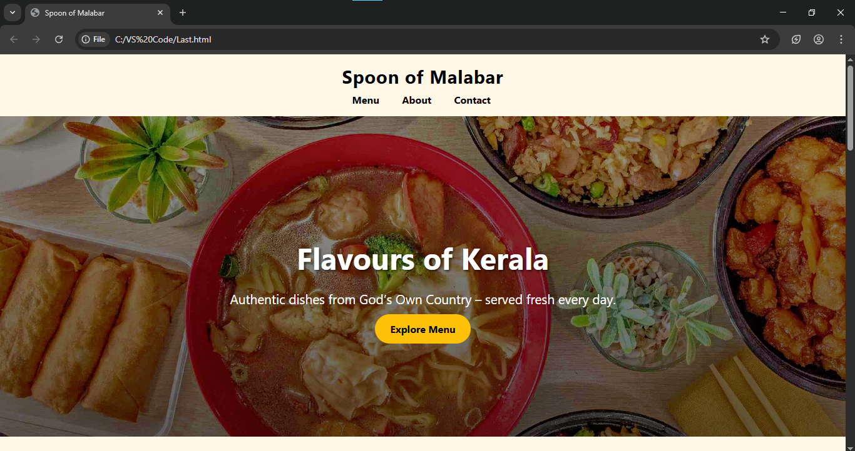

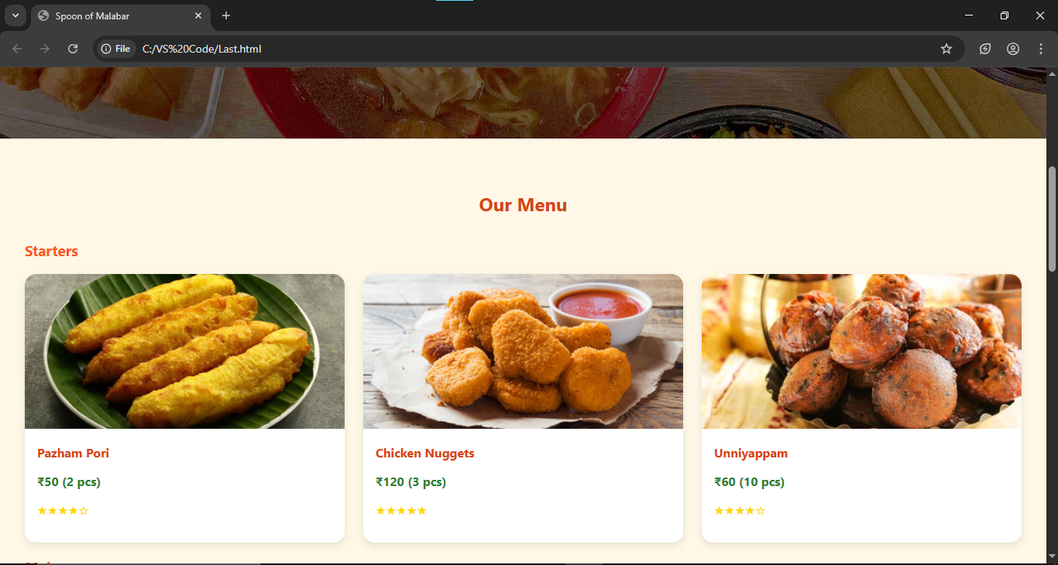

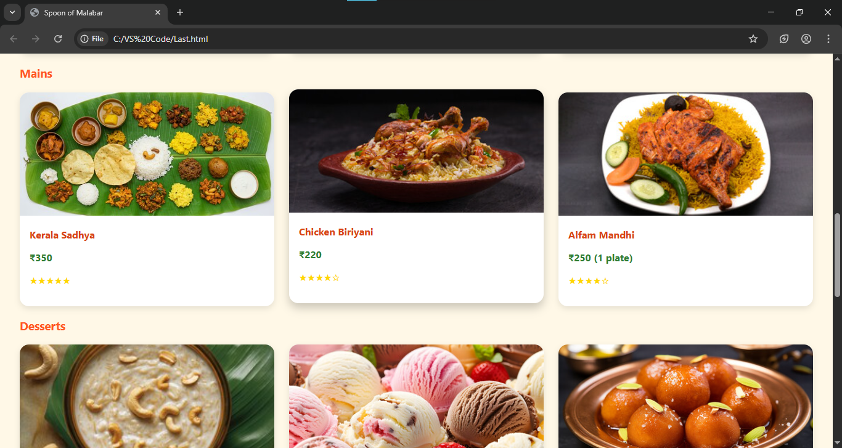

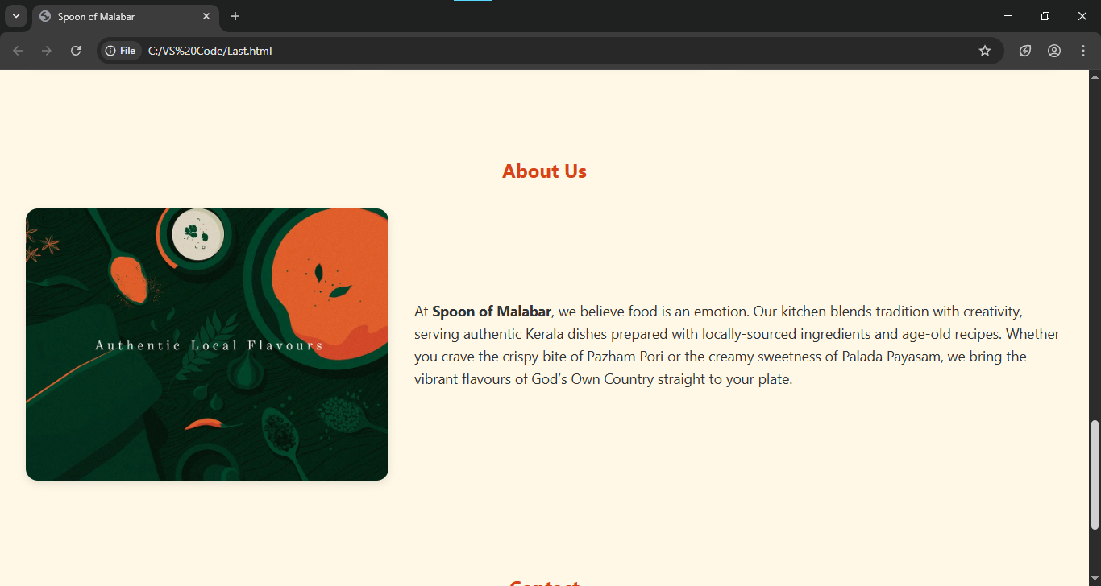

### *13. Conclusion*

The Spoon of Malabar website project has been an insightful experience in designing an engaging, responsive front-end. It reinforced skills in HTML structure, CSS styling, and UI/UX design for the food industry. The site can serve as a solid base for future functional enhancements, improving customer convenience and interaction.

### *14. References*

L&T LMS: https://learn.lntedutech.com/Landing/MyCourse  
Unsplash.com – Free stock images  
FontAwesome – Icons for UI elements